1b.
- TE10 versus TM11: Using the same WR-90 waveguide at f = 10 GHz, simulates both TE10 and TM11 modes. Determine fc, β and the E/H-field distributions for each mode. Calculate the theoretical cutoff frequencies using fc(mn)=c/2√[(m/a)²+(n/b)²]. Compare the results and justify why TE10 propagates at 10 GHz while TM11 does not.

Aim
To simulate and compare TE\(_{10}\) and TM\(_{11}\) modes in a WR-90 rectangular waveguide at 10 GHz using HFSS/MATLAB, and analyse their cutoff frequencies, propagation constants, and electric and magnetic field distributions.

Objectives
1. To calculate the theoretical cutoff frequencies of TE\(_{10}\) and TM\(_{11}\) modes using the WR-90 waveguide dimensions.
2. To determine the propagation constant \(\beta\) for each mode and verify whether it propagates at 10 GHz.
3. To simulate and analyse the electric-field (E-field) and magnetic-field (H-field) distributions for both modes.
4. To compare the simulation results with theoretical calculations and justify why TE\(_{10}\) propagates at 10 GHz while TM\(_{11}\) does not.
Program:

clc;
clear;
close all;

a = 22.86e-3;
b = 10.16e-3;
f = 10e9;
c = 3e8;

fc_TE10 = c/(2*a);
fc_TM11 = c/2*sqrt((1/a)^2+(1/b)^2);

k0 = 2*pi*f/c;

beta_TE10 = sqrt(k0^2-(pi/a)^2);
alpha_TM11 = sqrt((pi/a)^2+(pi/b)^2-k0^2);

fprintf('\n====================================\n');
fprintf(' TE10 AND TM11 MODE ANALYSIS\n');
fprintf('====================================\n');

fprintf('\nOperating Frequency = %.2f GHz\n',f/1e9);

fprintf('\n--- TE10 MODE RESULTS ---\n');
fprintf('Cutoff Frequency = %.4f GHz\n',fc_TE10/1e9);
fprintf('Propagation Constant = %.4f rad/m\n',beta_TE10);
fprintf('Attenuation Constant = 0 Np/m\n');

if f > fc_TE10
fprintf('Mode Status = PROPAGATING\n');
else
fprintf('Mode Status = BELOW CUTOFF\n');
end

fprintf('\n--- TM11 MODE RESULTS ---\n');
fprintf('Cutoff Frequency = %.4f GHz\n',fc_TM11/1e9);

if f > fc_TM11
beta_TM11 = sqrt(k0^2-(pi/a)^2-(pi/b)^2);
fprintf('Propagation Constant = %.4f rad/m\n',beta_TM11);
fprintf('Attenuation Constant = 0 Np/m\n');
fprintf('Mode Status = PROPAGATING\n');
else
fprintf('Propagation Constant = 0 rad/m\n');
fprintf('Attenuation Constant = %.4f Np/m\n',alpha_TM11);
fprintf('Mode Status = EVANESCENT\n');
end

fprintf('\n--- COMPARISON ---\n');

fprintf('TE10 cutoff = %.4f GHz\n',fc_TE10/1e9);
fprintf('TM11 cutoff = %.4f GHz\n',fc_TM11/1e9);

fprintf('\n--- FINAL RESULT ---\n');
fprintf('TE10 propagates at 10 GHz.\n');
fprintf('TM11 does not propagate at 10 GHz.\n');
fprintf('TE10 is the dominant mode.\n');

fprintf('\n====================================\n');

OUTPUT:
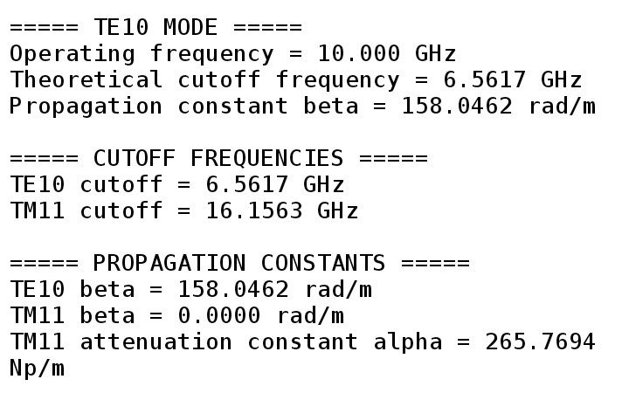
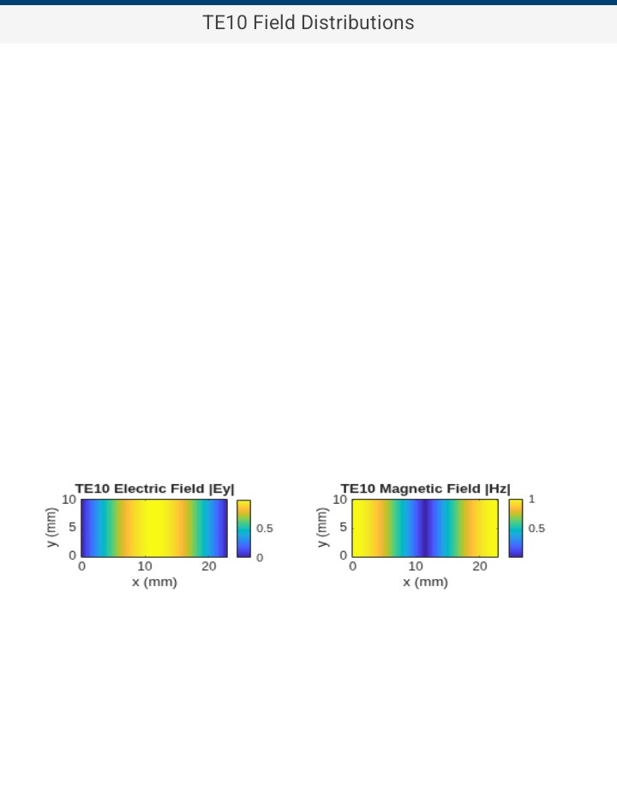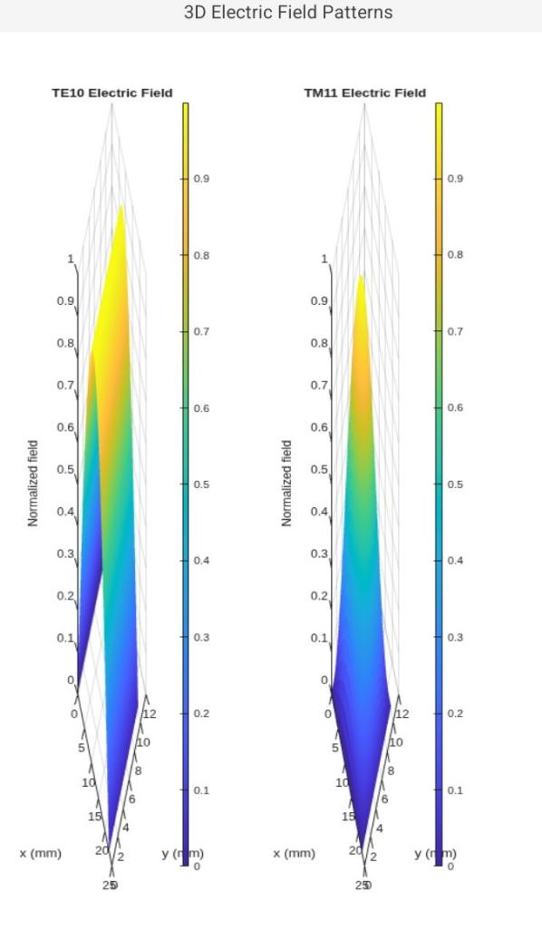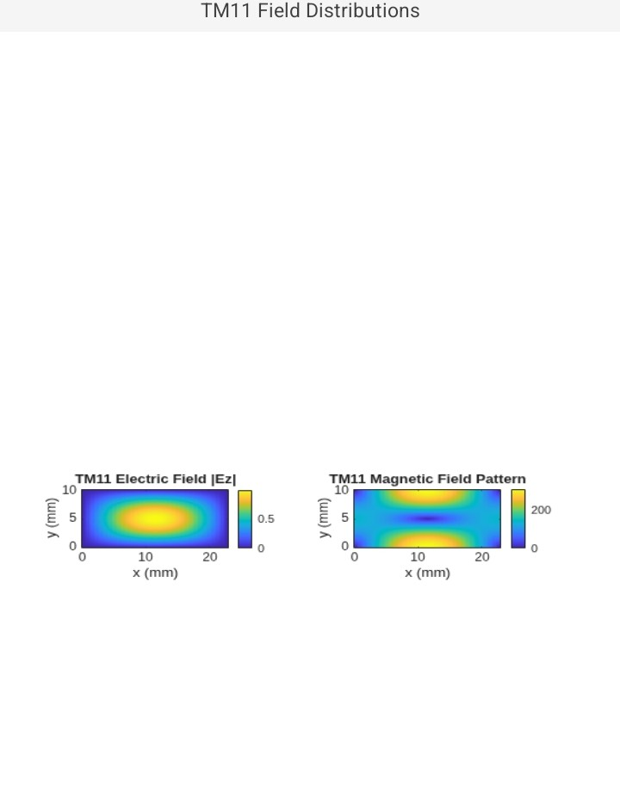
Result:

Thus the output is verified successfully and obtained cutoff frequencies as well as propagation constants.

